Weekly Lesson Plans-Intro to IT
4Jan | Classroom Management  Create Folders  UnHide File Extensions for known file types.  Go Over Website  Objectives  Operating Systems  Networking  Occupations  Software Applications  Hardware  Programming  Graphics  Multimedia  WebDesign
6Jan | Learning Target: (Objective 1) Explain Why it is essential to learn about computers today and discuss several ways computers are integrated into our business and personal lives.  Introduce Information to IT: Welcome to the world of computers.  Discuss how computers has affected you, just today, up to this moment in the day.  Write a five paragraph paper on occupations within the Information Technology world beginning with Occupation, Salary, Job Title/Description, Location, and Future.  Begin the paper with your thesis, connect each paragraph with transitions, close meaning properly and cited each resource.  Save the paper as 01IntroPaperLname and submit.
8Jan | Learning Target: (Objective 1) Explain Why it is essential to learn about computers today and discuss several ways computers are integrated into our business and personal lives.  Rewrite: Have the Teacher and Peers edit your draft paper. Complete a Rewrite with edit changes and submit. Again, save the paper as 01IntroPaperLname and submit.
12Jan | Learning Target: (Objective 2) Define a Computer and Describe its Primary Operations.  Write a list of hardware items needed to build a computer, cite parts with their order number, include all quotes for prices and total everything.  Get together in groups and discuss the compatibilities, needs, system requirements, and possible variations in uses.  Save the list as 02HardwareListLname and submit.
14Jan | Learning Target: (Objective 2) Define a Computer and Describe its Primary Operations.  Have each student go over each others list. Whose was the least/most expensive? Where did you order your parts from? Were they all from the same place? What was the shipping? Refine your lists and again, save them as 02HardwareListLname and submit.  Learning Target: (Objective 2) Build a Computer.  Have each student go over each others list. Whose was the least/most expensive? Where did you order your parts from? Were they all from the same place
16Jan | .  Learning Target: (Objective 4) Identify the major parts of a personal computer, including input, processing, output, storage, and communications hardware.  Finalize your hardware list. Now watch the following YouTube video of a computer being build here at MHS in 2014 and can also be searched under Liesingerjr:  Part 1: Building A Computer, MHS  https://www.youtube.com/watch?v=tE6ffD1lNqo&t=479s  Part 2(Case)  https://www.youtube.com/watch?v=v8U4sWJmBz4  Part 3(Power Supply)  https://www.youtube.com/watch?v=9e61J9-gfG0  Part 4(Motherboard)  https://www.youtube.com/watch?v=6XXIK175qf0  Part 5(Hard Drive)  https://www.youtube.com/watch?v=6XXIK175qf0  Part 6RAM)  https://www.youtube.com/watch?v=lXgwFEMQdrQ  Part 7(PCI Lan Card)  https://www.youtube.com/watch?v=I1DpaO-iupE  Part 8(Fans & Power Source)  https://www.youtube.com/watch?v=S105K1H26xU  Part 9(CPU Thermal Paste)  https://www.youtube.com/watch?v=pRNl8svN9Z4  Part10(Cables)  https://www.youtube.com/watch?v=fGnUBhpe98E
22Jan | Learning Target: (Objective 4) Identify the major parts of a personal computer, including input, processing, output, storage, and communications hardware.  Now, watch what we uploaded to YouTube in 2018-2019:  https://youtu.be/6Ri8Qi3vNBI  Have each assemble, disassemble, and store inventory for next class.  While each team member is performing their assembly, have the description of the part, and the installation recorded with video to update this class’s version on Youtube.com
24Jan | Learning Target: (Objective 4) Identify the major parts of a personal computer, including input, processing, output, storage, and communications hardware.  Complete the computer project.
28Jan | Learning Target: (Objective 4) Identify the major parts of a personal computer, including input, processing, output, storage, and communications hardware.  Download Video clips from the camera to both a desktop and the Y:Drive  Combine the Video clips into one movie using movie maker.  Upload the Final Video to YouTube.com and watch it.
30Jan | Learning Target: (Objective 3) List some important milestones in computer evolution.  Research the evolution of computers, include dates and milestones, and create a timeline of revelations up to and including projected technological advancements in the future.  Begin with an outline, cite your findings, include screenshots for pictures, and save the Word document as 03TechEvolutionTimelineLname and submit  Watch the Video parody on Broken Computer: https://www.youtube.com/watch?v=1JMuJ6Wy1j0&list=PL588C9A8EB4973AB0&index=7
1Feb | 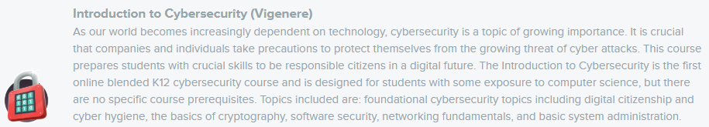  Learning Target: (Objective 5) PreTest CyberSecurity.  Students will enroll in CodeHS.com CyberSecurity class through an invitation from their teacher.    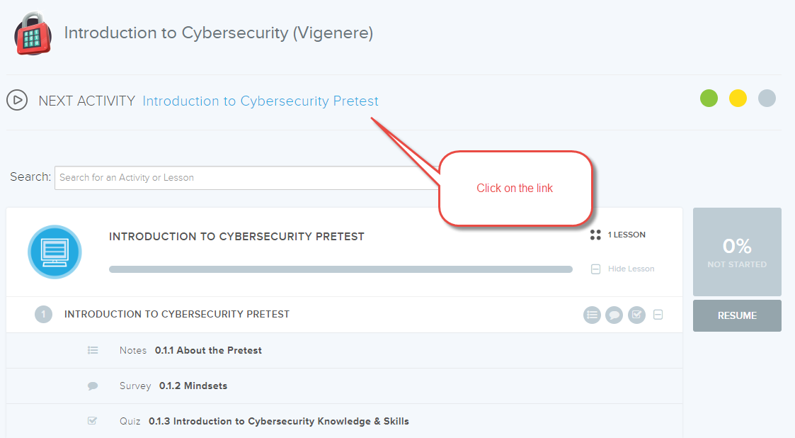  Students will begin the course with their pretest.  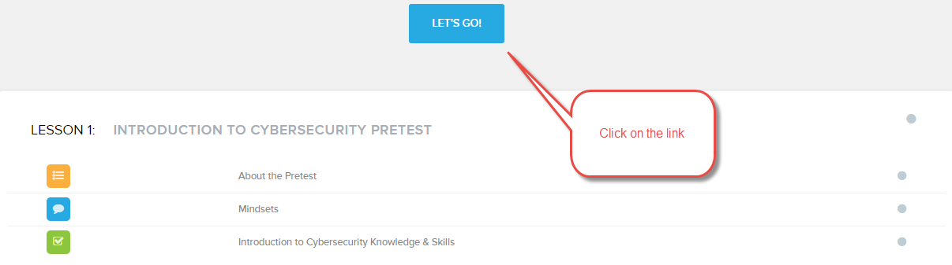  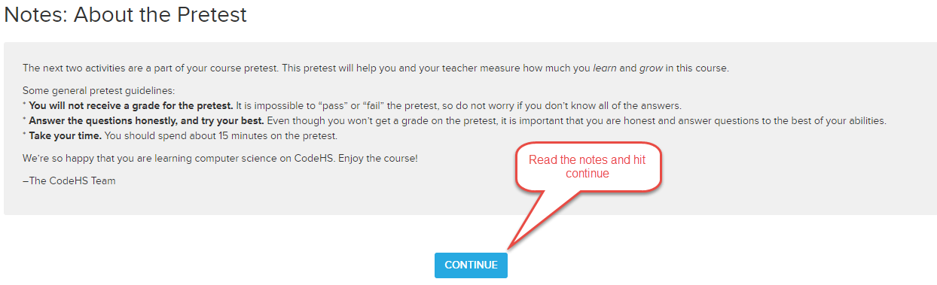  Take Quiz1Pretest, Check your answer every question, submit your results.  This is the end of the Pretest
5Feb | Log In to CodeHS.com and continue your “Progress” where you let off.  Learning Target: (Objective 6) Introduce CyberSecurity, why it is important, learn about recent threats and careers in the field.  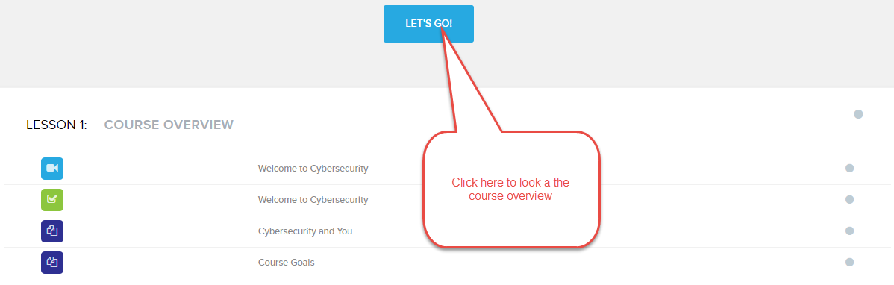  Learning Objective 6 (Lesson1.1) “Welcome to Cyber Security”  Watch the video    After the video, click “Continue” and  Learning Objective 6 (Lesson1.1.2) “Welcome to Cyber Security”  take the Quiz2WelcomeToCybSec  Learning Objective 6 (Lesson1.1.3) “CyberSecurity and You”  now do the essay questions  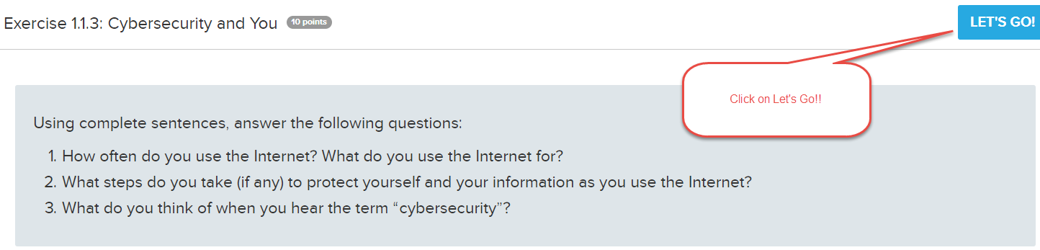  Click “Submit and continue with each completion.  Learning Objective 6 (Lesson1.1.4) “Course Goals”  Course Goals: just answer the question of what you want out of this course and submit.
11Feb | Log In to CodeHS.com and continue your “Progress” where you let off.  Learning Objective 6 (Lesson1.2.1) “Overview in Lesson 2”  Here is an overview of the modules in Lesson 2  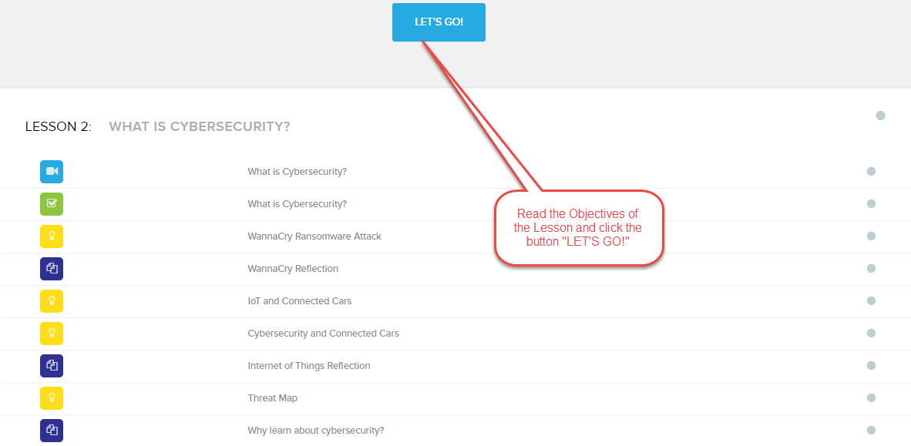
13Feb | Log In to CodeHS.com and continue your “Progress” where you let off.  Learning Objective 6 (Lesson.1.2.2) “What is Cyber Security”  Here is the first lesson with a quiz    Define Cyber Security  Internet of Things  CourseOverview  Take the quiz  Learning Objective 6 (Lesson1.2.3) “Ransomware Wanna Cry Attack”  Here is an overview of the modules in Lesson 2  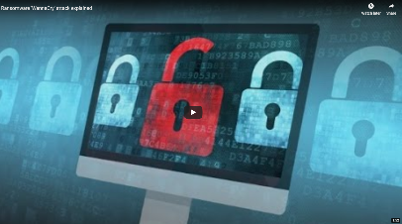  Maleware  Infected Hospitals  Locks computers  Pay in Bitcoins  Whose at Fault?  Still going today  Protect through Security Updates  Learning Objective 6 (Lesson1.2.4) “Wanna Cry Reflection”  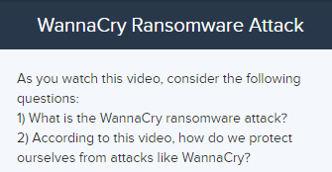  Here are the two question you need to answer while watching the Video and lesson on Ransomware
19Feb | 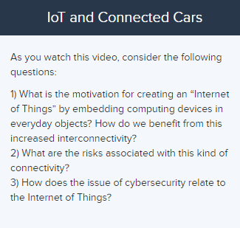  Log In to CodeHS.com and continue your “Progress” where you let off.  Learning Objective 6 (Lesson1.2.5) “Connected Cars Internet of Things(IoT) Explained”  Watch the video and as you are listening, think of these questions.  Learning Objective 6 (Lesson1.2.6) “CyberSecurity&Co”  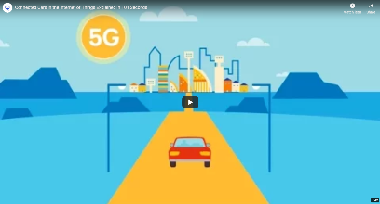  Learning Objective 6 (Lesson1.2.7) “InternetOfThings(IoT)”  Learning Objective 6 (Lesson1.2.8) “Threat Map”  Learning Objective 6 (Lesson1.2.9) “Why We Learn about Cyber Security”
22Feb | Log In to CodeHS.com and continue your “Progress” where you let off.  Learning Objective 6 (Lesson1.3.1) “ImpactOfCyberSecurity Overview”    Reliance on networks = Increase in Need  What is the Information at Risk?  Thoughts: Identify theft, Leaks, Financial, Business  Real World Examples  How does it pertain to you?  Learning Objective 6 (Lesson1.3.2) “ImpactOfCyberSecurity”  Learning Objective 6 (Lesson1.3.3) “Yahoo! Attack”  Learning Objective 6 (Lesson1.3.4) “Yahoo! Reflection”  Learning Objective 6 (Lesson1.3.5) “Fighting Cyber Crime”  Learning Objective 6 (Lesson1.3.6) “Cyber Crime Reflection”  Learning Objective 6 (Lesson1.3.7) “Cyber Crime”  Learning Objective 6 (Lesson1.3.8) “FBI Reflection”
27Feb | Open a browser and type in the URL https://meetedison.com and navigate around the site to get a feel for Edison Robots and some of the things you can do with them.  Learning Objective 6 (Lesson 1) “Power Up”  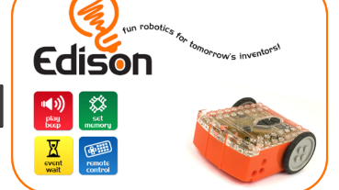  Watch the Video “Edison—Fun Robotics for Tomorrow’s Inventors. https://www.youtube.com/watch?v=skmVeFYgHCs  Watch the Video “Edison—Fun Robotics for Tomorrow’s Inventors. https://www.youtube.com/user/microbric?disable_polymer=true  Watch several other youtube videos and see all the possibilities.
1Mar | 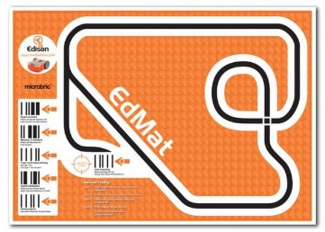  Watch the Video “Edison—Fun Robotics for Tomorrow’s Inventors. https://www.youtube.com/watch?v=skmVeFYgHCs  Learning Objective 6 (Lesson 2) “EdMat”  Bounce and Border  Suma Wrestling  Clap Control  Avoid Obstacles  Follow Torch Bar  Tracking Bar Code
6Mar | Learning Objective 6 (Lesson 2) “CodeEdisonRobots”  Watch the Video “EdScratch: Tutorial for Unit 1”. https://www.youtube.com/watch?v=skmVeFYgHCs  Watch the Video “EdWare: Tutorial 1 - Overview”.  https://www.youtube.com/watch?v=l8UuANc-COM  Practice  EdWare, continue with the series  EdScratch, continue with the series
8Mar | Log In to CodeHS.com and continue your “Progress” where you let off.    Learning Objective 6 (Lesson1.4.1) “CIA Trid Overview”  Confidentiality  Integrity  Availability  Learning Objective 1 (Lesson1.4.2) “Quiz: What is the CIA Triad”  Learning Objective 2 (Lesson1.4.3) “Which part of the CIA Triad?”  Learning Objective 3 (Lesson1.4.4) “Which part of the CIA Triad?”  Learning Objective 4 (Lesson1.4.5) “Which part of the CIA Triad?”  Learning Objective 5 (Lesson1.4.6) “Which part of the CIA Triad?”
12Mar |   Log In to CodeHS.com and continue your “Progress” where you left off.  Learning Objective 1 (Lesson1.5.1) “Unit Test—What is CyberSecurity”  Learning Objective 2 (Lesson1.5.2) “Intro to CyberSecurity Badge”      Log In to CodeHS.com and continue your “Progress” where you left off.  Learning Objective 1 (Lesson 2.1.1) “Digital Footprint & Reputation Overview”  Learning Objective 2 (Lesson 2.1.2) “Quiz—Digital Footprint & Reputation Overview”  Learning Objective 3 (Lesson 2.1.3) “Building a Positive Digital Footprint”  Learning Objective 4 (Lesson 2.1.4) “Right to be Forgotten”  Learning Objective 5 (Lesson 2.1.5) “Right to be Forgotten”  Learning Objective 6 (Lesson 2.1.6) “What is your Digital Footprint?”  Log In to CodeHS.com and continue your “Progress” where you left off.  Learning Objective 1 (Lesson 2.2.1) “CyberBullying Overview”  Learning Objective 2 (Lesson 2.2.2) “Quiz—Cyberbullying”  Learning Objective 3 (Lesson 2.2.3) “Scenario: Student Ranking”  Learning Objective 4 (Lesson 2.2.4) “Scenario: Singled Out”  Learning Objective 5 (Lesson 2.2.5) “Stopping CyberBullying”
18Mar | Log In to CodeHS.com and continue your “Progress” where you left off.  Learning Objective 1 (Lesson 2.3.1) “Internet Safety Overview”  Learning Objective 2 (Lesson 2.3.2) “Quiz—Internet Safety”  Learning Objective 3 (Lesson 2.3.3) “Scenario: School Stranger”  Learning Objective 4 (Lesson 2.3.4) “Scenario: Vacation Pals”  Learning Objective 5 (Lesson 2.3.5) “Staying Safe”  Log In to CodeHS.com and continue your “Progress” where you left off.  Learning Objective 1 (Lesson 2.4.1) “What is Data Privacy & Security? Overview”  Learning Objective 2 (Lesson 2.4.2) “Quiz—Privacy & Security”  Learning Objective 3 (Lesson 2.4.3) “Connection—How Strong is Your Password?”  Learning Objective 4 (Lesson 2.4.4) “Free Response—How Strong is Your Password?”  Learning Objective 5 (Lesson 2.4.5) “Connection—Google Privacy Policy Search”  Learning Objective 6 (Lesson 2.4.6) “Free Response—Google Privacy Policy Search II”  Log In to CodeHS.com and continue your “Progress” where you left off.  Learning Objective 1 (Lesson 2.5.1) “Video—Information Literacy, Overview”  Learning Objective 2 (Lesson 2.5.2) “Quiz—Information Literacy”  Learning Objective 3 (Lesson 2.5.3) “Free Response —Effective Internet Searches”  Learning Objective 4 (Lesson 2.5.4) “Connection —Evaluate the Source”  Learning Objective 5 (Lesson 2.4.5) “Free Response —Evaluate the Source”  Learning Objective 6 (Lesson 2.5.6) “Connection —Evalutate the Source”  Learning Objective 7 (Lesson 2.5.7) “Free Response —Evaluate the Source”  Learning Objective 8 (Lesson 2.5.8) “Connection —Hero Pig?”
20Mar | Log In to CodeHS.com and continue your “Progress” where you left off.  Learning Objective 1 (Lesson 2.6.1) “Video—Creative Credit & Copyright, Overview”  Learning Objective 2 (Lesson 2.6.2) “Quiz— Creative Credit & Copyright”  Learning Objective 3 (Lesson 2.6.3) “Free Response —Cite!”  Learning Objective 4 (Lesson 2.6.4) “Connection —Exploring Creative Commons”  Learning Objective 5 (Lesson 2.6.5) “Free Response — Creative Commons”  Learning Objective 6 (Lesson 2.6.6) “Free Response —Finding Images”  Learning Objective 7 (Lesson 2.6.7) “Free Response —Why is Copyright Important?”  Log In to CodeHS.com and continue your “Progress” where you left off.  Learning Objective 1 (Lesson 2.7.1) “Video—Hacking Ethics & Legality”  Learning Objective 2 (Lesson 2.7.2) “Quiz— Hacking Ethics & Legality”  Learning Objective 3 (Lesson 2.7.3) “Connection —Penetration Testing”  Learning Objective 4 (Lesson 2.7.4) “Free Response — Penetration Testing Reflection”  Learning Objective 5 (Lesson 2.7.5) “Connection — Hack the Pentagon?”  Learning Objective 6 (Lesson 2.7.6) “Free Response — Hack the Pentagon Reflection”  Learning Objective 7 (Lesson 2.7.7) “Quiz —Ethical Hacker Agreement”  Log In to CodeHS.com and continue your “Progress” where you left off.  Learning Objective 1 (Lesson 2.8.1) “Pick-A-Topic”  Learning Objective 2 (Lesson 2.8.2) “Research”  Learning Objective 3 (Lesson 2.8.3) “Choose your audience”  Learning Objective 4 (Lesson 2.8.4) “What kind of PSA?”(Public Service Announcment)  Learning Objective 5 (Lesson 2.8.5) “Draft your PSA?” Do .ppt or google slides.  Learning Objective 6 (Lesson 2.8.6) “Make your PSA!” Show to the class
22Mar |   Introduce to each student how Andrea Mosaic works. Students will have Andrea Mosaic loaded onto their Computers from the Tech Support Department.  Students will then find a picture that has simple theme with great contrast. An example of this would be a picture of a Motherboard. Create a Folder on your Desktop named Mosaic first. Then put your original picture with the simple theme inside that folder.  Students will then select 100 pictures that fit that simple theme. Place all those pictures in your folder on your desktop. Students will then declare the base picture as their theme, load the 100 and create a mosaic of the original base picture.  Save the PROJECT files as MosaicLname.am4 and save the PRODUCT MosaicLname.jpg.  Correct the Mosaic Project    Learning Target: Introduction to Multi Media. Introducing Animoto. Students find 50 pictures and put them all in one folder. Students will log into http://animoto.com. Select a theme that will fit your pictures, load the 50 pictures, select a theme appropriate site song and render the video.  Save the file as AnimotoLname.mp4  Correct the Animoto Project.    Students will make a graphic in Piktochart on Cyber Security:  - Occupations on Cyber Security(Treyton)  - General Information on Cyber Security(Tommy)  - Types of Threats in Cyber Security(Matt)  The site, text, and graphics can be found at: https://piktochart.com.  Correct the Pictochart Graphic
26Mar | Log In to CodeHS.com and continue your “Progress” where you left off.  Learning Objective 1 (Lesson 2.9.1) “Digital Citizenship & Cyber Hygiene Unit Quiz”  Learning Objective 2 (Lesson 2.9.2) “Digital Citizenship & Cybersecuirty Badge”
28Mar |     Log In to CodeHS.com and continue your “Progress” where you left off.  Learning Objective 1 (Lesson 3.1.1) Cryptography: A Brief History  Learning Objective 2 (Lesson 3.1.2) Cryptography, A Brief History Quiz  Learning Objective 3 (Lesson 3.1.3) Securing the Cloud  Learning Objective 4 (Lesson 3.1.4) Encryption Reflection  History of Cryptography  Log In to CodeHS.com and continue your “Progress” where you left off.  Learning Objective 1 (Lesson 3.2.1) Cryptography, Cryptology, Cryptanalysis, Movie  Learning Objective 2 (Lesson 3.2.2) Cryptography, Cryptology, Cryptanalysis, Quiz  Learning Objective 3 (Lesson 3.2.3) How the Enigma Worked, Connection  Learning Objective 4 (Lesson 3.2.4) How the Enigma Worked, Free Response  Learning Objective 5 (Lesson 3.2.5) Unknown Languages & Future of Crytogrpahy, Connection  Learning Objective 6 (Lesson 3.2.6) The Future of Cybersecurity, Free Response
1Apr |   Learning Objective 1 (Lesson 3.2.1) Copyrights  Watch the YouTube Video: https://www.youtube.com/watch?v=-9H6Ksp36q0  Watch the YouTube video: https://www.youtube.com/watch?v=gNcba878NAE  Watch the YouTube video: https://www.youtube.com/watch?v=Uiq42O6rhW4  Students will define and give examples on: The four factors of Fair Use  Test  Visit the link: https://www.crc.losrios.edu/library, then search Copyright from the CRC homepage  Vocab Terms: Students need to research this item and either write out definitions for each term or create an info graphic using Adobe Spark to illustrate Copyright Laws: Idea, Fact, Data, Logo, Trademark, Fair-use, Commentary, Parody., News Reporting, Scholarly Research, Education, First Sale, Attribution, Ignorance, Infringement, Ethics, Royalties, Permission  Students will explain the difference between Publicly Available vs Public Domain  Who said in March of 2013 to the Congressional Subcommittee on Courts, Intellectual Property, “But my point is, if one needs an army of lawyers to understand the basic precepts of the law, then it is time for a new law.”?  Students will then take a Quiz.  https://www.teachingtreasures.com.au/Danger%20zone/copyright-activity.htm  PHOTOSHOP:  Learning Target: Use Photoshop to make an Announcement  Below are some examples from Pintrest:  geawshtsrht  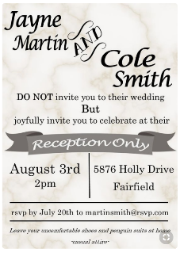    Students will make a “Save the Date” and an “Announcement” for a wedding. Use the examples above to complete. Save the photoshop files as SaveTheDateLname.psd, WeddingInviteLname.psd, and the picture files as SaveTheDateLname.jpg, WeddingInviteLname.jpg.
3Apr | Teacher: https://codehs.com/class/74827/lesson_plans/3433  Students: Why Engrypt?  Log In to CodeHS.com and continue your “Progress” where you left off.  Learning Objective 1 (Lesson 3.3.1) Why Encrypt, Movie  Learning Objective 2 (Lesson 3.3.2) Why Encrypt, Quiz  Students: Basic Crypto Systems: Caesar Cipher  Log In to CodeHS.com and continue your “Progress” where you left off.  Learning Objective 1 (Lesson 3.4.1) Caesar Cipher, Movie  Learning Objective 2 (Lesson 3.4.2) Caesar Cipher,, Quiz  Learning Objective 3 (Lesson 3.4.3) Caesar Cipher, Example  Learning Objective 4 (Lesson 3.4.4) Decrypting Caesar
5Apr | 3.5 Basic Crypto Systems: Cracking Caesar  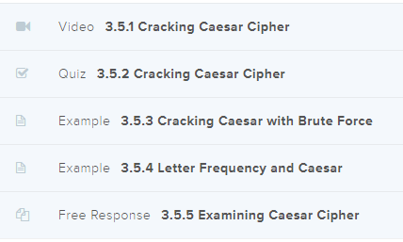  - Basic Crypto Systems: Vigenere Cipher  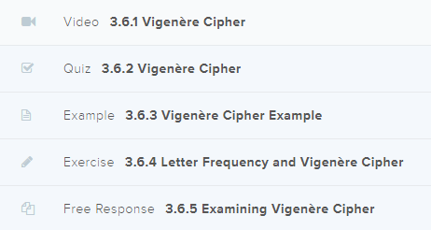
9Apr | 3.7Advanced Crypto  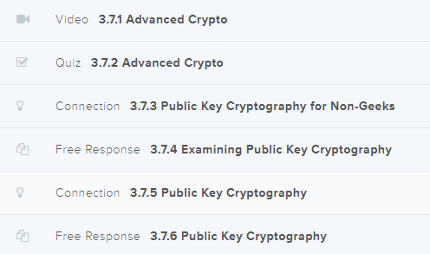  3.8Hash Functions  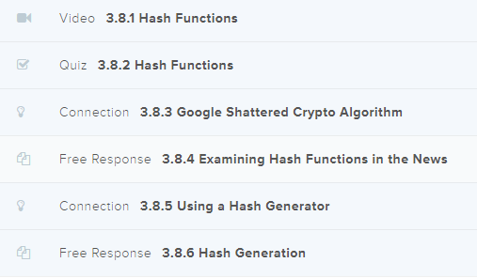
16Apr | 3.9Hash Functions Development  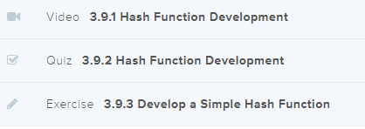  3.10Project Classic Cipher Newscast  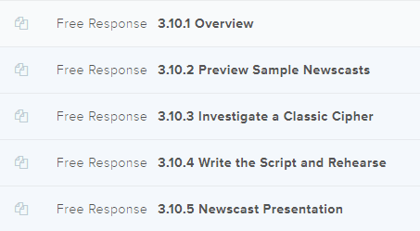
18Apr | 3.11ABCs. Of Cryptography Unit Quiz        Inside Web Apps  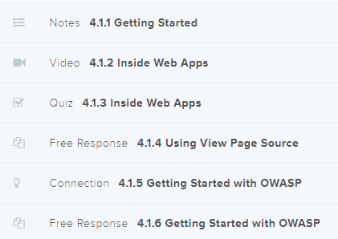  Developer tools  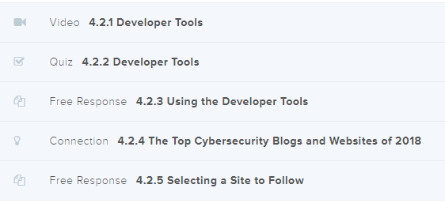  Databases  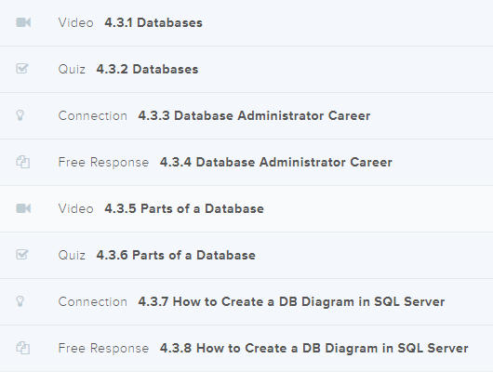  What is SQL  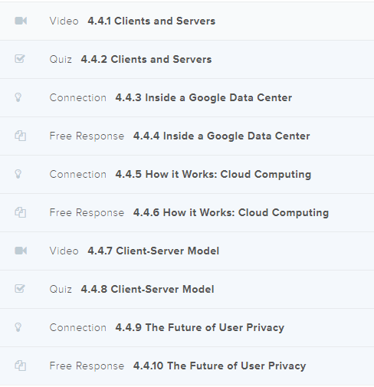
23Apr | Clients and Servers  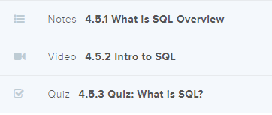  Structuring Data in SQL  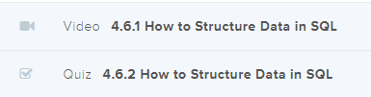  Basic Querying in SQL  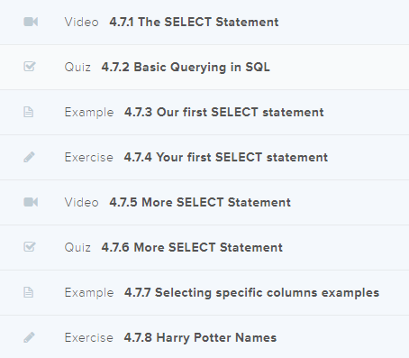
25Apr | Filtering Queries in SQL  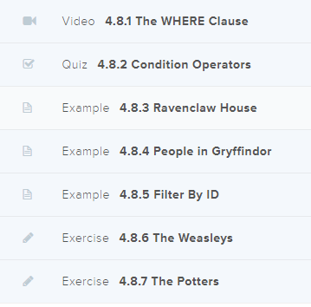  Editing Security Problems  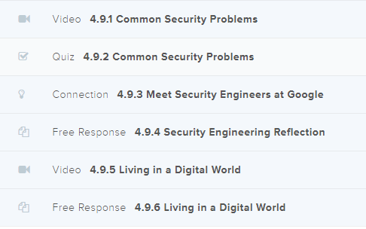  SQL Injection Overview  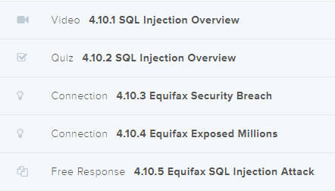
29Apr | Types of SQL and Prevention  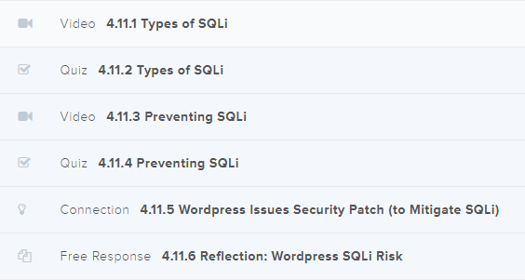  Cross-Site Scripting  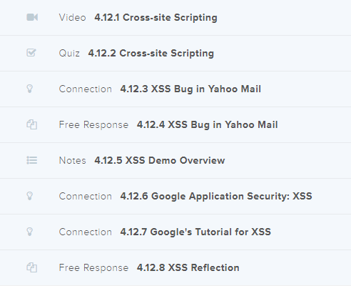  Software security unit quiz  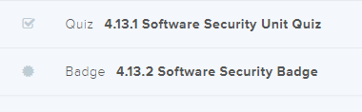
1May |     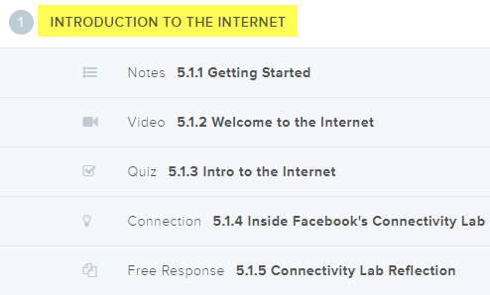  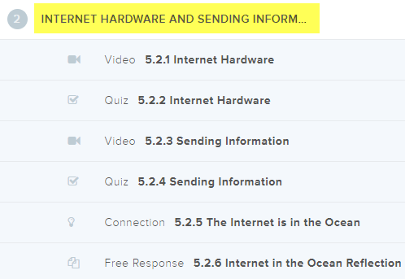  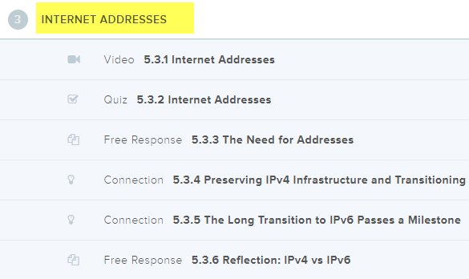
Golf  3May |   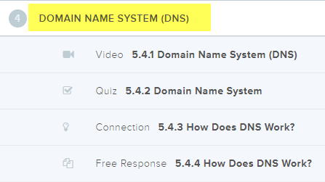  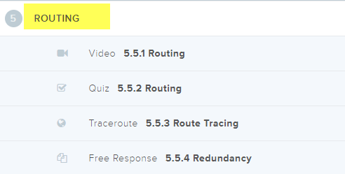  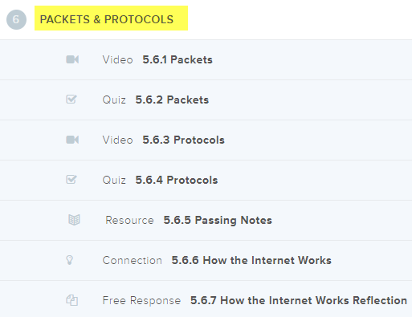
7May | 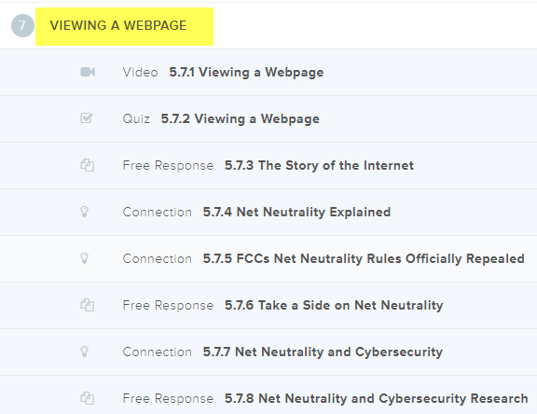  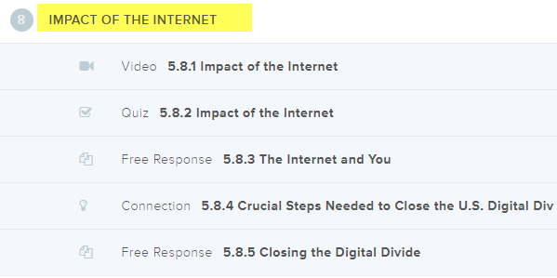  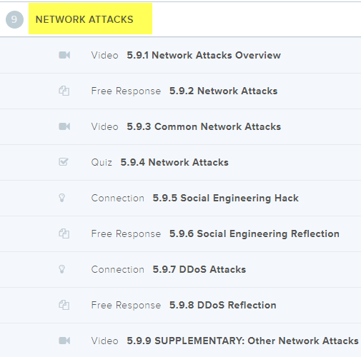
Golf  9May | 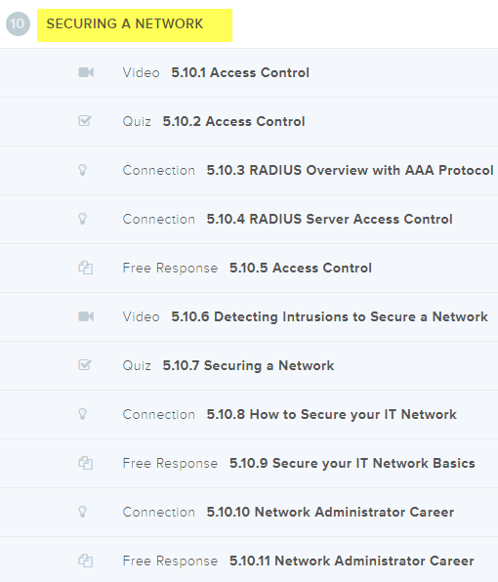  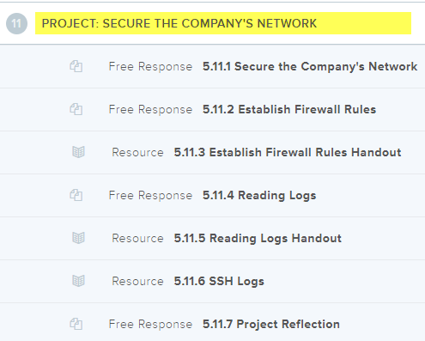  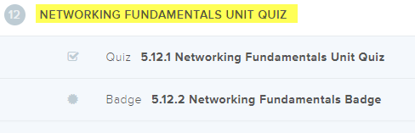
Golf  13May |   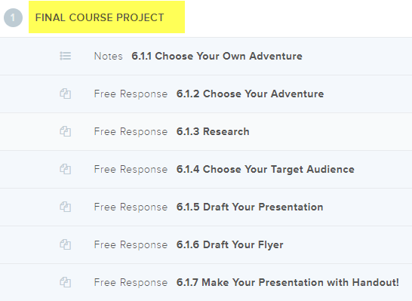    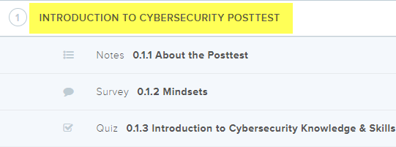
15May | Catch-Up Day, Grading All Assignments
17May | Complete Final Project Exam
21May | Complete Final Written Exam
24May  Final Exam | Correct Final Project Exam
28May  Final Exam | Correct Final Written Exam
A/B Day  29May | Check Out  Students will rotate every 10 minutes through all eight classes and check out.  Early Out, Turn In Equipment  Show and Tell Other Classes
 | How to Build a Firewall:

Innovation and Problem-Solving:
Don Wettrick’s Website: listen to the podcast
https://www.cultofpedagogy.com/innovation-class/
https://www.cultofpedagogy.com/pod/episode-83/
Have to:
Should do:
Want to:
Learning Target: (Objective 5) Define software and understand how it is used to instruct the computer what to do.

Operating System
Application Software
Free Downloads
Anti-Virus

CYBER SECURITY
Tether Mobile Hotspot
Cat 5
Learning Target: (Objective 6) List the six basic types of computers, giving at least one example of each type of computer and stating what that computer might be used for.
Continue Reading Chapter 1 (pages 20-31)
Continue Power Point Chapter 1

Learning Target: Jeopardy for Chapter 1
Create a Jeopardy board for Chapter 1.
Open a Word Document, insert a table with 6 columns by 12 rows.
Fill in each cell of the first column from the top with: Catagories, 100Q, 100A, 200Q, 200A, 300Q, 300A, 400Q, 400A, 500Q, 500A.
Merge and Center all of the cells in the last row.
Split the one cell in the last row into two columns.
Fill in the first cell of the last row with a Final Jeopardy question.
Fill in the second cell of the last row with the Final Jeopardy answer.

Save the file as IT1JeopardyLname.docx
13Feb | Learning Target: (Objective 7) Explain what a network, the Internet, and the World wide web are, as well as how computers, people, and Web pages are identified on the Internet.  Continue Reading Chapter 1 (Page 32-34)  Continue Power Point Chapter 1  Now we will begin to build our template for a Jeopardy board, fill in your data from the IT1JeopardyLname.docx document you created to complete your game.  Use Topics or Categories by Section  Now use the Word Document and create a Jeopardy Game from the template.  Save the file as IT1JeopardyLname.ppt.  Turn them in.
Learning Target: (Objective 8) Describe how to Access a Web Page.
Continue Reading Chapter 1(page 34-42)
Continue Power Point Chapter 1

Summary: Review the Chapter 1 Summary. Open the teacher’s Objective Questions and complete 1-9. Save the file as IT1ObjectiveQuestionsLname and submit. Answers are found in the summary.

Review: Each Student will show their Jeopardy board to review for the test.
Learning Target: (Objective 9) Discuss the societal impact of computers, including some benefits and risks related to their prominence in our society.
Continue Reading Chapter 1 (page 42-51)
Continue Power Point Chapter 1

You are finished with Chapter One and your e-files should look like this:
IT1ObjectiveQuestionsLname
IT1RATermsLname
IT1RAExercisesLname
IT1RASelfQuizLname
IT1ChapJeopardyLname.docx
IT1ChapJeopardyLname.ppt
IT1SelfQuizLname
IT1PracticeTestLname
IT1TermsLname
IT1ExercisesLname
IT1PaperLname
IT1DefineComputerLname

Chapter 1 Test, found your data files from the Y:Drive. IntroToITTestChapter01 and begin. Save the file as IT1TestLname.

This finishes Chapter 1.

Corrected the Test
Begin reading Chapter 2.

Learning Target (Objective 1): Understand how data and programs are represented to a computer and be able to identify a few of the coding systems used to accomplish this.
Reading Chapter 2
Present Power Point on Chapter 2
Students Take Notes.
Complete the Review Activities Terms. Save the file as IT2RATermsLname and submit.
Correct the Review Activities Terms.
Complete the Matching Terms. Save the file as IT2TermsLname and submit.
Correct the Terms.

Complete the Review Activities Exercises. Save the file as IT2RAExercisesLname and submit.
Correct the Review Activities Exercises.
Complete the Exercise. Save the file as IT2ExercisesLname and submit.
Correct the Exercises
Learning Target (Objective 2): Explain the function of the hardware components commonly found inside the system unit, such as the CPU, memory, buses, and expansion cards.
Continue to use Chapter 2 and the Power Point for resources.

Complete the Review Activity Self-Quiz. Save the file as IT2RASelfQuizLname and submit.
Correct the Review Activity Self Quiz.
Complete the Self-Quiz. Save the file as IT2SelfQuizLname and submit.
Correct the Self Quiz

Learning Target: Practice Test for Chapter 2
Save the file as IT2PracticeTestLname and submit.
Correct the Practice Test
Learning Target (Objective 3): Describe how peripheral devices or other hardware can be added to a PC.
Continue to use Chapter 2 and the Power Point for resources.

Learning Target: Jeopardy for Chapter 2
Create a Jeopardy board for Chapter 2.
Open a Word Document, insert a table with 6 columns by 12 rows.
Fill in each cell of the first column from the top with: Catagories, 100Q, 100A, 200Q, 200A, 300Q, 300A, 400Q, 400A, 500Q, 500A.
Merge and Center all of the cells in the last row.
Split the one cell in the last row into two columns.
Fill in the first cell of the last row with a Final Jeopardy question.
Fill in the second cell of the last row with the Final Jeopardy answer.

Save the file as IT2JeopardyLname.docx
Learning Target (Objective 4): Understand how the computer system’s CPU and memory components process program instructions and data.
Continue to use Chapter 2 and the Power Point for resources

Now we will begin to build our template for a Jeopardy board, fill in your data from the IT2JeopardyLname.docx document you created to complete your game.

Use the Chapter “Objective for Categories
Now use the Word Document and create a Jeopardy Game from the template.

Save the file as IT2JeopardyLname.ppt.
Turn them in.
Learning Target (Objective 5): Name and evaluate several strategies that can be used today for speeding up the operations of a computer.
Continue to use Chapter 2 and the Power Point for resources.

Learning Target: Base Two Numbering System for Binary Coding and other Base Numbering Systems.
Students will learn how to convert different numbers in different bases back and forth between bases two, four, five, ten, and sixteen by completing the worksheet. Name the Worksheet IT2BaseNumberingLname and submit.

Correct the Base Numbering Worksheet.

Learning Target: Chapter 2 Summary Objectives

Review the Chapter 2 Summary. Open the teacher’s Objective Questions and complete all questions in detail. Save the file as IT2ObjectiveQuestionsLname and submit.
Learning Target (Objective 6): List some processing technologies that may be used in future PCSs.
Continue to use Chapter 2 and the Power Point for resources.

Learning Target (Assessment): Test Review
Watch Jeopardy Examples

Learning Target (Assessment): Test

You are finished with Chapter 2 and your e-files should look like this:
IT2RATermsLname
IT2TermsLname
IT2RAExercisesLname
IT2ExercisesLname
IT2RASelfQuizLname
IT2SelfQuizLname
IT2PracticeTestLname
IT2BaseNumberingSystemLname
IT2ObjectiveQuestionsLname
IT2JeopardyGame.doc
IT2JeopardyGame.ppt

Chapter 2 Test, found your data files from the Y:Drive. IntroToITTestChapter02 and begin. Save the file as IT2TestLname.

This finishes Chapter 2. .
Learning Target (Objective 1): Name several general characteristics of storage systems.
Read Chapter 3
Present Power Point Chapter3

Reading Chapter 3
Present Power Point on Chapter 3
Students Take Notes.
Complete the Review Activities Terms. Save the file as IT3RATermsLname and submit.
Correct the Review Activities Terms.
Complete the Matching Terms. Save the file as IT3TermsLname and submit.
Correct the Terms.

Complete the Review Activities Exercises. Save the file as IT3RAExercisesLname and submit.
Correct the Review Activities Exercises.
Complete the Exercise. Save the file as IT3ExercisesLname and submit.
Correct the Exercises

Complete the Review Activity Self-Quiz. Save the file as IT3RASelfQuizLname and submit.
Correct the Review Activity Self Quiz.
Complete the Self-Quiz. Save the file as IT3SelfQuizLname and submit.
Correct the Self Quiz
Learning Target Objective 2: Describe how magnetic disk systems (such as hard drives) work.
Read Chapter 3
Present Power Point Chapter3

Learning Target: Practice Test for Chapter 3
Save the file as IT3PracticeTestLname and submit.
Correct the Practice Test
Learning Target (Objective 3): Discuss the various types of optical disc systems available and how they differ from each other and from magnetic systems.
Read Chapter 3
Present Power Point Chapter 3

Learning Target: Jeopardy for Chapter 3
Create a Jeopardy board for Chapter 3.
Open a Word Document, insert a table with 6 columns by 12 rows.
Fill in each cell of the first column from the top with: Catagories, 100Q, 100A, 200Q, 200A, 300Q, 300A, 400Q, 400A, 500Q, 500A.
Merge and Center all of the cells in the last row.
Split the one cell in the last row into two columns.
Fill in the first cell of the last row with a Final Jeopardy question.
Fill in the second cell of the last row with the Final Jeopardy answer.

Save the file as IT3Lab1JeopardyLname.docx

Now we will begin to build our template for a Jeopardy board, fill in your data from the Objective Questions in this Chapter’s Summary Section into the Blank Power Point Provided.

Save the file as IT3Lab2JeopardyLname.ppt.
Turn them in.

HARDWARE
Now we are going to watch a video on how to make a computer. Before we do this, we are going to watch this video on building something different, but what is important about this video is that you can see how the NewEgg website works when ordering parts. The link can be found on YouTube at: https://www.youtube.com/watch?v=vJzHrFhQuvw&feature=youtu.be#t=1035.03
Learning Target (Objective 4): Identify some flash-memory-based storage devices and media and explain how they are used today.
Read Chapter 3
Present Power Point Chapter3

Play all the Jeopardy Games

HARDWARE
Create a Hardware List, From any source they would like. Save it in a Word Documents as IT3Lab3HardwareListLname.doc
Learning Target (Objective 5): List at least three other types of storage systems.
Read Chapter 3
Present Power Point Chapter3

Review the Chapter 3 Summary. Open the teacher’s Objective Questions and complete all questions in detail. Save the file as IT3ObjectiveQuestionsLname and submit.

Correct the Objective Questions.

Learning Target (Assessment): Test Review

HARDWARE
Add to your Hardware List the prices of each item and insert a picture into the word document to include the link where you found it. Save it in the same Word Document however this time save it as IT3Lab4HardwarePricesLname.doc
Learning Target (Assessment): Test

You are finished with Chapter 3and your e-files should look like this:
IT3RATermsLname
IT3RAExercisesLname
IT3RASelfQuizLname
IT3ObjectiveQuestionsLname
IT3Lab1Jeopardy.docx
IT3Lab2Jeopardy.ppt
IT3SelfQuizLname
IT3PracticeTestLname
IT3TermsLname
IT3Exercises
IT3Lab3HardwareListLname.doc
IT3Lab4HardwarePricesLname.doc

Chapter 3 Test, found your data files from the Y:Drive. IntroToITTestChapter03 and begin. Save the file as IT3TestLname.

This finishes Chapter3

HARDWARE
Now we are going to watch a video on how to make a computer. This video about the parts was made by a previous class and placed on Youtube. The link can be found at:

https://youtu.be/tE6ffD1lNqo
https://www.youtube.com/watch?v=tE6ffD1lNqo&feature=youtu.be

HARDWARE
Now we are going to watch a video on how to make a computer. This video about the case was made by a previous class and placed on Youtube. The link can be found at:
https://youtu.be/v8U4sWJmBz4
https://www.youtube.com/watch?v=v8U4sWJmBz4&feature=youtu.be

HARDWARE
Now we are going to watch a video on how to make a computer. This video about the power supply was made by a previous class and placed on Youtube. The link can be found at:

https://youtu.be/9e61J9-gfG0
https://www.youtube.com/watch?v=9e61J9-gfG0&feature=youtu.be

Learning Target: Introduce Chapter 4: Input and Out-Put Storage
Read Chapter 4 (pg 138-141)
Present Power Point Chapter 4

Learning Target Objective 1: Explain the purpose of a computer keyboard and the types of key boards widely used today.
Students: Open a browser, find three keyboards that are most popular and widely used today. Take a screen shot of each. Place the screenshots in a Word document. Note the source of the screenshot. Insert the cost of the keyboard. Separate the cost of shipping and note that dollar amount as well. List any system requirements necessary. List the features like USB or Wireless, etc. Save the file as IT4KeyboardPurposeLname and submit.

Learning Target: Review Activities Exercises for Chapter 4
Teacher: Go over the Review Activity for Chapter 4 Exercises.
Students: Complete the RAExercises. Save the file as IT4RAExercisesLname and submit.

Learning Target: Exercises for Chapter 4.
Teacher Go over the Exercises for Chapter 4.
Students: Complete the Exercises. Save the file as IT4ExercisesLname and submit.

HARDWARE
Now we are going to watch a video on how to make a computer. This video about the motherboard and was made by a previous class and placed on Youtube. The link can be found at:
https://youtu.be/6XXIK175qf0
https://www.youtube.com/watch?v=6XXIK175qf0&feature=youtu.be
Learning Target: Continue Chapter 4: Input and Out-Put Storage
Read Chapter 4 (141-148)
Continue Present Power Point Chapter 4

Learning Target Objective 2: List several different point devices and describe the functions
Students: Open a browser, find three pointing devices that are most popular and widely used today. Take a screen shot of each. Place the screenshots in a Word document. Note the source of the screenshot. Insert the cost of each item. Separate the cost of shipping and note that dollar amount as well. List any system requirements necessary. List the features like USB or Wireless, etc. and describe the functions. Save the file as IT4PointDevicesPurposeLname and submit.

Learning Target: Review Activities Terms for Chapter 4
Teacher: Go over the Review Activity Terms for Chapter 4.
Students: Complete the RAMatching Terms. Save the file as IT4RATermsLname and submit.

Learning Target: Terms for Chapter 4.
Teacher Go over the Terms for Chapter 4.
Students: Complete the Terms. Save the file as IT4TermsLname and submit.
Learning Target: Continue Chapter 4: Input and Out-Put Storage
Read Chapter 4 (pg 148-158)
Continue Present Power Point Chapter 4

Learning Target Objective 3: Describe the purposes of scanners and readers and list some types of scanners and readers in use today.
Students: Open a browser, find at least five scanners that are most popular and widely used today. Take a screen shot of each. Place the screenshots in a Word document. Note the source of the screenshot. Insert the cost of each item. Separate the cost of shipping and note that dollar amount as well. List any system requirements necessary. List the features like USB or Wireless, Copies, Color, etc. Save the file as IT4ScannerPurposeLname and submit.

Learning Target: Review Activities Self Quiz for Chapter 4
Teacher: Go over the Review Activity for Chapter 4.
Students: Complete the RASelfQuiz. Save the file as IT4RASelfQuizLname and Submit.

Learning Target: Self Quiz for Chapter 4.
Teacher Go over the Self Quiz for Chapter 4.
Students: Complete the Self-Quiz. Save the file as IT4SelfQuizLname and submit
Learning Target: Continue Chapter 4: Input and Out-Put Storage
Read Chapter 4 (pg 158-160)
Continue Present Power Point Chapter 4

Learning Target Objective 4: Understand how digital cameras differ from conventional cameras.
Students: Open a browser, find digital cameras that are most popular and widely used today. Take a screen shot of each. Place the screenshots in a Word document. Note the source of the screenshot. Insert the cost of each item. Separate the cost of shipping and note that dollar amount as well. List any system requirements necessary. List any relevant features, etc. Save the file as IT4CamerasPurposeLname and submit.

Learning Target: Taking a Practice Test
Students: Complete the Practice Test. Save the file as IT4PracticeTestLname and submit.

Learning Target: Continue Chapter 4: Input and Out-Put Storage
Continue Read Chapter 4 (pg 160-162)
Present Power Point Chapter 4

Learning Target Objective 5: Explain how audio input is accomplished.
Students: Open a browser, find voice & music input systems that are most popular and widely used today. Take a screen shot of each. Place the screenshots in a Word document. Note the source of the screenshot. Insert the cost of each item. Separate the cost of shipping and note that dollar amount as well. List any system requirements necessary. List any relevant features, etc. Save the file as IT4AudioInputLname and submit.

Learning Target: Continue Chapter 4: Input and Out-Put Storage
Continue Read Chapter 4 (pg 162-172)
Present Power Point Chapter 4

Learning Target Objective 8: Understand the hardware devices used for audio out-put.
Students: Open a browser, find Audio output systems that are most popular and widely used today. Take a screen shot of each. Place the screenshots in a Word document. Note the source of the screenshot. Insert the cost of each item. Separate the cost of shipping and note that dollar amount as well. List any system requirements necessary. List any relevant features, etc. Save the file as IT4AudioOutputLname and submit.

Learning Target: Introduction to Multi Media: Introducing Audacity audio editing program. Students will have a demonstration on creating, recording, editing, layering, importing, and exporting digital audio files. Make a Ringtone: Save the file as IT4Lab3RingtoneLname.aup and export the project as IT4Lab4RingtoneLname.mp3.

Learning Target: Continue Chapter 4: Input and Out-Put Storage
Continue Read Chapter 4 (pg 172-178)
Present Power Point Chapter 4

Learning Target Objective 7: List several types of printers and explain their functions.
Students: Open a browser, find printers that are most popular and widely used today. Take a screen shot of each. Place the screenshots in a Word document. Note the source of the screenshot. Insert the cost of each item. Separate the cost of shipping and note that dollar amount as well. List any system requirements necessary. List any relevant features, etc. Save the file as IT4APrintersLname and submit.

Learning Target: Continue Chapter 4: Input and Out-Put Storage
Continue Read Chapter 4 (pg 179-179)
Present Power Point Chapter 4

Learning Target Objective 6: Describe the characteristics of a display device and explain some of the technologies used to display images.
Students: Open a browser, find display devices that are most popular and widely used today. Take a screen shot of each. Place the screenshots in a Word document. Note the source of the screenshot. Insert the cost of each item. Separate the cost of shipping and note that dollar amount as well. List any system requirements necessary. List any relevant features, etc. Save the file as IT4DisplayDevicesLname and submit.

HARDWARE
Now we are going to disassembly a brand new computer desktop that was made by a previous class. Each part will be disassembled, packed in its original box, and then reassembled by each student.
Learning Target: Continue Chapter 4: Input and Out-Put Storage
Continue Read Chapter 4 (pg 180-181)
Present Power Point Chapter 4

Learning Target: Review the Chapter 4 Summary.
Students Open the teacher’s Objective Questions and complete all questions in detail. Save the file as IT4ObjectiveQuestionsLname and submit.

Now we will begin to build our template for a Jeopardy board, fill in your data from the IT4Lab1JeopardyLname.docx document you created to complete your game.

Use the Chapter “Objective for Categories
Now use the Word Document and create a Jeopardy Game from the template.

Save the file as IT4Lab2JeopardyLname.ppt.
Turn them in.

HARDWARE
Now students are going to take a test on hardware components. They will have to study what each piece is called when pointed to. Students will also have to develop a list of the minimum number of components to build a computer through the boot process.
Learning Target: Assessment of Chapter 4.
Chapter 4 Test, found on the Y:Drive, IntrotoITTestChapter04, copy, paste, and begin.
Save the file as IT4TestLname.

You are finished with Chapter 4and your e-files should look like this:
IT4KeyboardPurposeLname
IT4RAExercisesLname
IT4ExercisesLname
IT4PointingDevicePurposeLname
IT4RATermsLname
IT4TermsLname
IT4ScannerPurposeLname
IT4RASelfQuizLname
IT4SelfQuizLname
IT4CameraPurposeLname
IT4PracticeTestLname
IT4AudioInputLname
IT4DisplayDevicesLname
IT4PrintersLname
IT4AudioOutPutLname
IT4ObjectiveQuestionsLname
IT4Lab1JeopardyLname.doc
IT4Lab2JeopardyLname.ppt
IT4Lab3RingtoneLname.aup
IT4Lab4RingtoneLname.mp3
IT4TestLname
This finishes Chapter 4.
Correct the Chapter 04 Test

Learning Target: Introduce Chapter 5: System Software: Operating Systems and Utility Programs

Objective 1: Understand the difference between system software and application software.
Read Chapter 5 (190-192)
Present Power Point Chapter 5
Learning Target: Review Activity Terms for Chapter 5
Teacher: Go over the Review Activity for Chapter 5 Terms.
Students: Complete the Review Activity Terms. Save the file as IT5RATermsLname and Submit.

Objective 2: Explain the different functions of an operating system and discuss some ways that operating systems can differ from one another.
Read Chapter 5 (192-196)
Present Power Point Chapter 5
Learning Target: Exercises for Chapter 5
Teacher: Go over the Review Activity for Chapter 5 Exercises. Save the file as IT5RAExercisesLname and Submit.

Objective 3: List several ways in which operating systems enhance processing efficiency.
Read Chapter 5 (196-199)
Present Power Point Chapter 5
Learning Target: Self Quiz for Chapter 5
Teacher: Go over the Review Activity for Chapter 5 Self-Quiz. Save the file as IT5RASelfQuizLname and Submit.

HARDWARE
Now students are going to take a test on hardware components. They will have to study what each piece is called when pointed to. Students will also have to develop a list of the minimum number of components to build a computer through the boot process.
Correct the Review Activity Terms
Correct the Review Activity Exercises
Correct the Review Activity Self Quiz

Learning Target Objective 4: Name Today’s most widely used operating systems for desktop PCs and servers.
Learning Target: Terms for Chapter 5
Teacher: Go over the Terms for Chapter 5.
Students: Complete the Matching Terms. Save the file as IT5TermsLname and submit.

Learning Target: Exercises for Chapter 5
Teacher: Go over the Exercises for Chapter 5.
Students: Complete the Exercises. Save the file as IT5ExercisesLname and submit.

Learning Target: SelfQuiz for Chapter 5
Teacher: Go over the SelfQuiz for Chapter 5.
Students: Complete the SelfQuiz. Save the file as IT5SelfQuizLname and submit.

HARDWARE
Now students are going to take a test on hardware components. They will have to study what each piece is called when pointed to. Students will also have to develop a list of the minimum number of components to build a computer through the boot process.
Learning Target: Introduction to Multi Media. Introducing Photoshop. Students build a map of a lot using different tools and layers. Save the file as IT5Lab5PhotoshopLname.psd and export the project as IT5Lab6PhotoshopLname.jpg. This assignment will be graded on 1) Lasso Tool, 2) Layers 3) Adjustment Layers 4) Clone Stamp Tool 5) Healing Brush Tool 6) Color Picker 7) Opacity 8) Fill 9) Move Tool 10) Transform Tool 11) Blurs, 12) Liquify Tools and is work 100 points.

HARDWARE
Now students are going to take a test on hardware components. They will have to study what each piece is called when pointed to. Students will also have to develop a list of the minimum number of components to build a computer through the boot process.
Continue with Lab5 and Lab6

Learning Target: Introduction to Multi Media. Introducing Photoshop. Students continue working on the map now using different fills, gradients, and textures for different layers. Save the file as IT5Lab5PhotoshopLname.psd and export the project as IT5Lab6PhotoshopLname.jpg. See Above.

HARDWARE
Now students are going to take a test on hardware components. They will have to study what each piece is called when pointed to. Students will also have to develop a list of the minimum number of components to build a computer through the boot process.
Begin Lab 7 and Lab 8

Learning Target: Create a Photoshop Project on Your Own. Introducing Photoshop. Students find two pictures and change the background in one of them using the fore-front of the other. Save the file as IT5Lab7PhotoshopLname.psd and export the project as IT5Lab8PhotoshopLname.jpg.

HARDWARE
Now students are going to take a test on hardware components. They will have to study what each piece is called when pointed to. Students will also have to develop a list of the minimum number of components to build a computer through the boot process.
Continue Lab 7 and Lab 8

Learning Target Objective 5: State several devices other than desktop PCs and Servers that require an operating system and list one possible operating system for each type of device.
Complete the Practice Test. Save the file as IT5PracticeTestLname and submit.

Learning Target Objective 6: Discuss the role of utility programs and outline several duties that these programs perform..
Review the Chapter 5 Summary. Open the teacher’s Objective Questions and complete all questions in detail. Save the file as IT5ObjectiveQuestionsLname and submit.

Correct Practice Test
Correct Objective Questions
Correct Lab 5 & 6
Correct Lab 7 & 8

Introduce Animoto
Introduce Photostory
Introduce Andrea Mosaic

Learning Target Objective 7: Describe what the operating systems of the future might be like. Operating System Essay
Learning Target: Assessment of Chapter 5.
Chapter 5 Test, found on the Y:Drive, IntrotoITTestChapter05, copy, paste, and begin.
Save the file as IT5TestLname
You are finished with Chapter 5 and your e-files should look like this:
IT5RATermsLname
IT5RAExercisesLname
IT5RASelfQuizLname
IT5TermsLname
IT5ExercisesLname
IT5SelfQuizLname
IT5PracticeTestLname
IT5IT5ObjectiveQuestionsLname
IT5Lab5PhotoshopLname.psd
IT5Lab6PhotoshopLname.jpg
IT5Lab7PhotoshopLname.psd
IT5Lab8PhotoshopLname.jpg
IT5Lab9AnimotoLname.mp4
IT5Lab10MosaicListLname.am4
IT5Lab11MosiacLname.jpg
This finishes Chapter 5.
Correct the Test for Chapter 5.

Learning Target: Introduction to Multi Media. Introducing Animoto. Students find 50 pictures and put them all in one folder. Students will log into http://animoto.com. Select a theme that will fit your pictures, load the 50 pictures, select a theme appropriate site song and render the video.
Save the file as IT5Lab9 Animoto.mp4

Correct the Animoto Project.
Introduce to each student how Andrea Mosaic works. Students will have Andrea Mosaic loaded onto their Computers from the Tech Support Department.

Students will then find a picture that has simple theme with great contrast. Create a Folder on your Desktop named Mosaic first. Then put your original picture with the simple theme inside that folder.

Students will then select 100 pictures that fit that simple theme. Place all of those pictures in your folder on your desktop.

Students will then declare the base picture as their theme, load the 100 and create a mosaic of the original base picture. not be able to accomplish this project because of software permissions.

Save the PROJECT files as IT5Lab10 Mosaic ListLname.am4 and save the PRODUCT IT5Lab11 Mosaic Lname.jpg.
Correct the Mosaic Project
Show the class how to make a PhotoStory video, with the use of their Audacity knowledge and skills.
Save the PRODUCT files as ITLab12 PhotoStoryLname.wmv and save the PROJECT file as IT5Lab13 PhotoStoryLname.ps3.
Correct the Mosaic Projects.
Learning Target: Introduce Chapter 6: Application Software:
Standard: IT3.3Describe different types and purposes of productivity software.
Read Chapter 6
Present Power Point Chapter 6
Review Activities (Terms, & Exercises)

Learning Target Objective 1: Describe What application software is, the different types of ownership rights, and the difference between installed and Web-based software.
Complete the Exercises.
Learning Target: Review Activity Terms for Chapter 6
Teacher: Go over the Review Activity for Chapter 6 Terms.
Students: Complete the Review Activity Terms. Save the file as IT6RATermsLname and Submit.

Learning Target Objective 2: Detail some concepts and commands that many software programs have in common.
Students: Complete the Matching Terms. Save the file as IT6TermsLname and submit.

Learning Target Objective 3: Discuss word processing and explain what kinds of documents are created using this type of program.
Teacher: Go over the Review Activity for Chapter 6 Exercises. Save the file as IT6RAExercisesLname and Submit.

Learning Target Objective 4: Explain the purpose of spreadsheet software and the kinds of documents created using this type of program.
Students: Complete the Self-Quiz. Save the file as IT6ExercisesLname and submit.
Learning Target: Continue Chapter 6: Application Software:
Standard: IT3.3Describe different types and purposes of productivity software.
Read Chapter 6
Present Power Point Chapter 6
Review Activities (Self Quiz)
Practice Test & Objective Questions

Learning Target Objective 5: Identify some of the vocabulary used with database software and discuss the benefits of using this type of program.
Teacher: Go over the Review Activity for Chapter 6 Self-Quiz. Save the file as IT6RASelfQuizLname and Submit.

Learning Target Objective 6: Describe what presentation graphics and electronic slide shows are and when they might be used.
Students: Complete the Matching Terms. Save the file as IT6SelfQuizLname and submit.

Learning Target Objective 7: List some types of graphics and multimedia software consumers use frequently.
Complete the Practice Test. Save the file as IT6PracticeTestLname and submit.

Learning Target Objective 8: Name other types of application software programs and discuss what function they perform.
Review the Chapter 6 Summary. Open the teacher’s Objective Questions and complete all questions in detail. Save the file as IT6ObjectiveQuestionsLname and submit.
Assessment of Chapter 6.
Chapter 6 Test, found on the Y:Drive, IntrotoITTestChapter06, copy, paste, and begin.
Save the file as IT6TestLname.

You are finished with Chapter 6 and your e-files should look like this:
IT6ObjectiveQuestionsLname
IT6RAExercisesLname
IT6RATermsLname
IT6RASelfQuizLname
IT6SelfQuizLname
IT6PracticeTestLname
IT6TermsLname
IT6TestLname
IT6Exercises
This finishes Chapter 6.

Correct the test.
 | Pirates of Silicon Valley
Learning Target: Introduce Chapter 7: Computer Networks

Objective 1: Define a network and its purpose.
Read Chapter 7 (274-276)
Present Power Point Chapter 7

Learning Target: Review Activity Terms for Chapter 7
Teacher: Go over the Review Activity for Chapter 7 Terms.
Students: Complete the Review Activity Terms. Save the file as IT7RATermsLname and Submit.

Objective 2: Describe several uses for communications technology.
Read Chapter 7 (276-284)
Present Power Point Chapter 7

Learning Target: Review Activity Terms for Chapter 7
Teacher: Go over the Terms for Chapter 7 Terms.
Students: Complete the Review Activity Terms. Save the file as IT7TermsLname and Submit.

Corrected Test
Reviewed Adobe After Effects
Chroma Keying
Puppet Tool
Flash CS3
Motion Tween
Shape Tween
Illustrator CS3
Pen Tool
Watched Animotos

 | Review for Final Exam
Final Exam(Computer Turn-In for Spring Semesters)

Indicator 1: Understand the need for Digital Technologies within daily life
IT1.1: Define how digital electronics devices and computers are related.
- List the Electronic Devices That you have used or shared within the last week.
IT1.2: Provide an explanation of the fundamentals of telecommunications, computer networking, the Internet, and wireless networking.
- Explain how communication takes place electronically
IT1.3: Describe functional areas in which computers assist people
- List the top 10 Social Blunders and Explain Cause-Effect relationships
IT1.4: Discuss the uses of information systems for individuals and industry
- Explain some careers associated with different types of Information Systems
IT1.5: Define information security and how technologies impact society
- What is ID theft, how is it used, list some symptons, and explain who to correct it.

Indicator 2: Understand computer hardware to meet specific needs
IT2.1: Understand how computer information is represented
- Define the four major characteristics of a computer
IT2.2: Identify hardware components and their relationshiop to computer usage.
- Convert 1001 base two to Decimal and 231 base ten to Binary
IT2.3: Understand the different types of memory and storage
- What is the difference between volatile and non-volatile memory?
IT2.4: Identify input and output devices to meet the needs of users.
- How do input and output devices connect to a computer?
IT2.5: Understand the decision-making process involved in purchasing a computer system
- What are the two most important things to consider after identifying your needs when purchasing a personal computer?

Indicator 3: Understand Software Solutions for Personal and Professional Use
IT3.1: Explain how software is created, distributed, installed , and maintained.
- Explain Copyright and licensing issues
IT3.2: Describe the function of system software and operating systems.
- What is the purpose of system software?
IT3.3: Describe different types and purposes of productivity software
- List some popular software and their manufacturers

Indicator 4: Understand Technology used for the Internet and the World Wide Web
IT4.1: Describe how the Internet Developed
- List Major Internet Milestones
IT4.2: Explain how hardware, protocols, and software work together to create the Internet.
- List the seven layers of the OSI model
IT4.3: Explain the underlying structures and technologies used to support the internet.
- Identify 3 main internet connections and explain how they differ
IT4.4: Explain what Internet2 is and the types of applications it will provide in the future.
- What is the goal for Internet2 and what is the current record?
 | Final
 | Chapter 10. Click on Student Labs--while in Student Labs hover over the orange highlighted items for an explanation, Select the first Lab: Working with Graphics. Complete the Introduction, Observation, Practice, and Review for: Introduction to Working with Graphics, Bit-mapped Graphics, Downloading Images from the Web, Enhancing an Image with Filters, Manipulating Brightness, Contrast, and Sharpness, Incorporating Type in an Image, Working with Layers, Cropping vs. Resizing; Reducing File Size, and Web Graphics. Select the second Lab: Working with Audio. Complete the Introduction, Observation, Practice, and Review for: Sound and Music, File Formats and Extensions, Importing Audio Files, Downloading Audio Files, Burning Audio CDs, and Including Audio Files on a Web Site. Select the Third Lab: Working with Video. Complete the Introduction, Observation, Practice, and Review for: Viewing Digital Video, Getting Started, Importing Clips, Using the Storyboard, Working with Clips, Adding Transitions, Including Audio, and Saving the Video. Exit from Presentation Software (or minimize it). Open your teacher's version of the Student Lab Worksheet. Put your answers in the teacher's version worksheet. Highlight your answers in yellow. Save it as IntroToIT10StudentLabLname and email it.
 | Chapter 9. Click on Student Labs--while in Student Labs hover over the orange highlighted items for an explanation, Select the first Lab: Keeping Your Computer Virus Free. Complete the Introduction, Observation, Practice, and Review for: Introduction to Keeping Your Computer Virus Free, Antivirus Software, Virus Detection, and Virus Prevention. Exit from Presentation Software (or minimize it). Open your teacher's version of the Student Lab Worksheet. Put your answers in the teacher's version worksheet. Highlight your answers in yellow. Save it as IntroToIT9StudentLabLname and email it.
 | Chapter 8. Click on Student Labs--while in Student Labs hover over the orange highlighted items for an explanation, Select the first Lab: Connecting to the Internet. Complete the Introduction, Observation, Practice, and Review for: Establishing an Internet Connection, Dial-up Connections, DSL, Cable, Wireless, Installing ISP Software, Creating Connections Manually, and Disconnecting. Select the second Lab: Getting the Most Out of the Internet. Complete the Introduction, Observation, Practice, and Review for: Starting on the Internet, Keeping Track of Your Favorite Sites, Customizing Your Browser, Searching the Web, Online Job Hunting, Online Travel Reservations, and Building Communities. Exit from Presentation Software (or minimize it). Open your teacher's version of the Student Lab Worksheet. Put your answers in the teacher's version worksheet. Highlight your answers in yellow. Save it as IntroToIT8StudentLabLname and email it.
 | Chapter 7. Click on Student Labs--while in Student Labs hover over the orange highlighted items for an explanation, Select the first Lab: Networking Basics. Complete the Introduction, Observation, Practice, and Review for: Network Architecture, Network Hardware, Network Software, Other Ways to Connect, Network Protocols, and Utilities, Networked Resources, and Network Security. Select the second Lab: Wireless Networking. Complete the Introduction, Observation, Practice, and Review for: Overview of Wireless Networking, Implementing Wireless Networks, and Wireless Security. Exit from Presentation Software (or minimize it). Open your teacher's version of the Student Lab Worksheet. Put your answers in the teacher's version worksheet. Highlight your answers in yellow. Save it as IntroToIT7StudentLabLname and email it.
 | Chapter 6. Click on Student Labs--while in Student Labs hover over the orange highlighted items for an explanation, Select the first Lab: Word Processing. Complete the Introduction, Observation, Practice, and Review for: Opening a Document, Moving the Insertion Point, Entering Text, Editing Text, Moving and Deleting Blocks of Text, Formatting, Inserting Fraphics, Checking Spellings, Saving and Print, and Creating Web Pages. Select the second Lab: Spreadsheets. Complete the Introduction, Observation, Practice, and Review for: Understanding Columns, Rows, and Cells, Entering Labels, Values, and Formulas, Selecting and Naming Ranges, Moving and Coping, Inserting Functions, Formatting a Worksheet, Creating a Chart, and Printing a Worksheet. Select the third Lab: Databases. Complete the Introduction, Observation, Practice, and Review for: How to Use Tables and forms to View Data, Creating a Table, Entering and Editing Data, Relationships Between Tables, Sorting Data, Creating an Index, Creating Queries, Applying Filters, Searching for Data, Creating and Modifying Reports. Select the fourth Lab: Presentation Software. Complete the Introduction, Observation, Practice, and Review for: Adding Text to Slides, Adding Graphics to Slides, Adding Animation to Slides, Adding Sound to Slides, Using Slide Layouts, Using Themes, Understanding the Slide Maste, Rearranging and Deleting Slides, Viewing a Presentation, and Previewing and Printing Presentations. Exit from Presentation Software (or minimize it). Open your teacher's version of the Student Lab Worksheet. Put your answers in the teacher's version worksheet. Highlight your answers in yellow. Save it as IntroToIT6StudentLabLname and email it.
 | Chapter 5. Click on Student Labs--while in Student Labs hover over the orange highlighted items for an explanation, Select the first Lab: Backing Up Your Computer. Complete the Introduction, Observation, Practice, and Review for: Creating a Backup, Creating an Incremental Backup, Scheduling Backup Jobs, Restoring an entire backup, Restoring a Single File. Select the second Lab: Maintaining Your Hard Drive. Complete the Introduction, Observation, Practice, and Review for: Introduction to Hard Disk Drives, Defragmenting a Hard Disk Drive, Running ScanDisk, Detecting System and Program Failures, Freeing Up Disk Space. Exit from Presentation Software (or minimize it). Open your teacher's version of the Student Lab Worksheet. Put your answers in the teacher's version worksheet. Highlight your answers in yellow. Save it as IntroToIT5StudentLabLname and email it.
 | Chapter 4. Click on Student Labs--while in Student Labs hover over the orange highlighted items for an explanation, Select the first Lab: Using Input Devices. Complete the Introduction, Observation, Practice, and Review for: Parts of a Mouse, Moving a Mouse, Clicking and Double-Clicking, Dragging, Right Clicking, Parts of a Keyboard, Typing Keypad, Function Keys, Navigation Keypad, Numeric Keypad, Other Input Devices. Select the second Lab: Using Peripheral Devices. Complete the Introduction, Observation, Practice, and Review for: Using Display Devices, Using Printers, Using Scanners, Using Digital Cameras, Using Storage Devices. Exit from Presentation Software (or minimize it). Open your teacher's version of the Student aLab Worksheet. Put your answers in the teacher's version worksheet. Highlight your answers in yellow. Save it as IntroToIT4StudentLabLname and email it.
 | Chapter 3. Click on Student Labs--while in Student Labs hover over the orange highlighted items for an explanation, Select the only Lab: Managing Files and Folders. Complete the Introduction, Observation, Practice, and Review for: Introduction to Mnaging Files and Folders, Saving and Opening Files, Using Windows Explorer, Opening and Closing Folders, Deleting and Restoring Files, Creating and Naming Folders, Copying and Moving Folders, Changinf Folder Options and Properties. Exit from Presentation Software (or minimize it). Open your teacher's version of the Student Lab Worksheet. Put your answers in the teacher's version worksheet. Highlight your answers in yellow. Save it as IntroToIT3StudentLabLname and email it.
 | Chapter 2. Click on Student Labs--Note: while in Student Labs hover over the orange highlighted items for an explanation. Select the first Lab: Binary Numbers. Complete the Introduction, Observation, Practice, and Review for: Introduction to Binary Digits, Comparing Binary and Decimal Number Systems, Manual Conversion, Using Windows Calculator. Select the second Lab: Understanding the Motherboard. Complete the Introduction, Observation, Practice, and Review for: Introduction to Understanding the Motherboard, Integrated Circuits, CPU, RAM, ROM, Expansion Slots and Expansion Cards. Exit from Presentation Software (or minimize it). Open your teacher's version of the Student Lab Worksheet. Put your answers in the teacher's version worksheet. Highlight your answers in yellow. Save it as IntroToIT2StudentLabLname and email it.
 | Chapter 1. Click on Student Labs--while in Student Labs hover over the orange highlighted items for an explanation, Select the first Lab: Using Windows. Complete the Introduction, Observation, Practice, and Review for: Common Elements of Windows, Working with the Taskbar and Start Menu, Arranging Windows, Using Menus, Using Toolbars, Using Dialog Boxes, Changing the Display Properties. Select the second Lab: Email. Complete the Introduction, Observation, Practice, and Review for: Composing a Message, Replying to a Message, Printing Mail, Using the Address Book, Working with Attachments, Deleting a Message, Moving Messages, Signing Up for Web-based E-mail, Using Web-based E-Mail. Exit from Presentation Software (or minimize it). Open your teacher's version of the Student Lab Worksheet. Put your answers in the teacher's version worksheet. Highlight your answers in yellow. Save it as IntroToIT1StudentLabLname and save the document on a flash drive until we correct it as a class.
 | Classroom Management, Syllabus, File Management

